

**Manawatu Branch**

*New Zealand China*

*Friendship Society*

**February Newsletter 2016**

**

*According to the Chinese zodiac the monkey possesses such character traits as curiosity, mischievousness, and cleverness. Forever playful, monkeys are the masters of practical jokes. Even though their intentions are always good, this desire to be a prankster has a tendency to create ill will and hurt feelings.  Monkeys prefer urban life to rural, and their favourite pastime is people-watching.*

Next Meeting February 13th

*Yum Cha Lunch*

*to celebrate the Year of the Monkey*

*12 noon at China Town Restaurant*

The demand for tables at China Town restaurant at this time of year is always great. By booking early Hilary has managed to secure two tables for a total of 20 people. If you wish to come please let Hilary know before February 8th, email: [hils.keith@xtra.co.nz](mailto:hils.keith@xtra.co.nz) ph 3586155.

**Visit of Northwest Chinese Womens’ Handicraft Delegation**

Three women handicraft workers and cooperative leaders arrived in Christchurch on Saturday 14th November last year accompanied by Liu Guozhong; cooperative organiser. After visiting interesting parts of rural Canterbury (Springfield, Oxford, Amberley etc) they travelled to Nelson to meet Nelson Branch members and local handicraft producers. They arrived in Palmerston North on Thursday 19th after travelling across Cook Strait aboard the Picton ferry. The three women delegates were :-

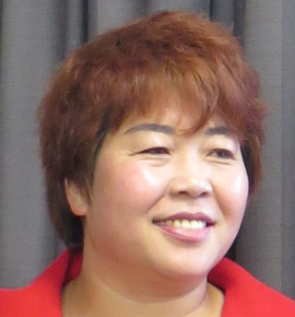

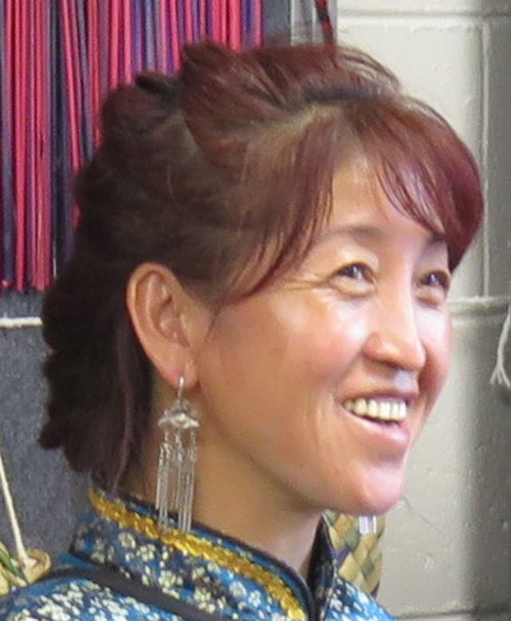

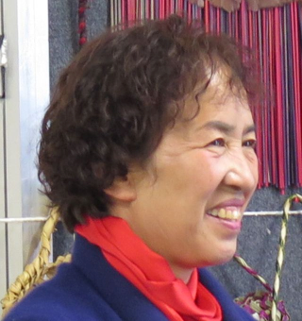

At Our Last Meeting

Han Xiaoqin from the Sunan county Mati Feitian Embroidery Association who demonstrated Yugu-style embroidery

Zhu Ernu from the Minhe county Tu Minority Embroidery Association who demonstrated Tu- style embroidery

Zuo Huanrong from the Qingyang Hongtai Sachet Embroidery Association who demonstrated Han-style embroidery

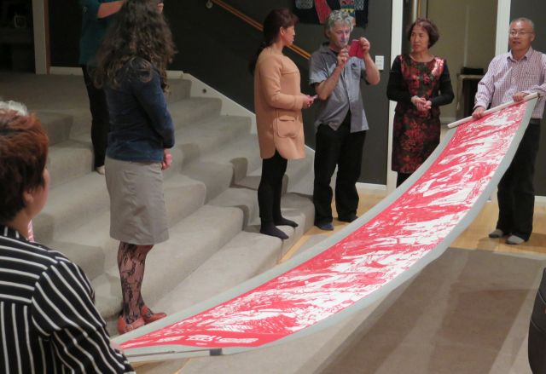

Obituary

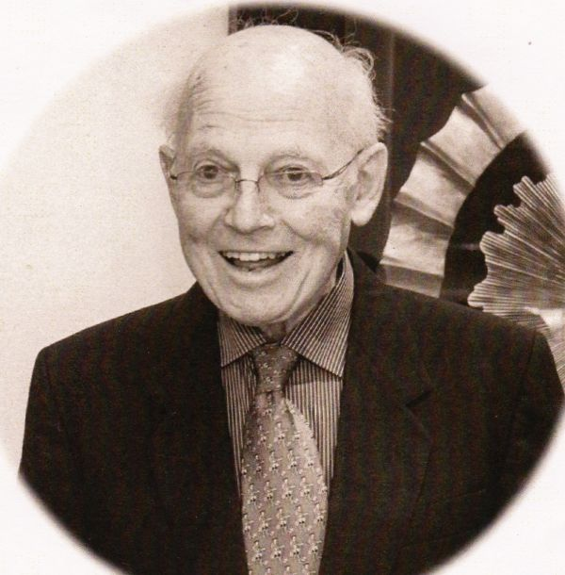

Paul was a foundation member of the Manawatu Branch of the New Zealand China Friendship Society. He died on the 14th November aged 85. He was born in Essex in 1930 and was one of twin boys. He experienced the blitz in London first hand and subsequently joined the RAF. After the war he graduated from the London School of Economics and worked in the civil service before he came to Massey University as a lecturer in Comparative Economic Systems. In 1976 he went to Beijing to study Chinese language and teach English at Beijing University for 2 years. He enjoyed travelling and had a great enthusiasm for Chinese and other cultures which he shared with Branch members. Paul was the first Branch President at a time when association with China was unpopular and he worked continuously to improve NZ/China relationships. His three great passions were reading, cooking and gardening and his favourite quotation:

“ If you have a garden and a library you have everything you need.” (Cicero).

Paul Hamer

*Unrolling a long papercut frieze depicting the evolution of agriculture in Northwest China*

After meeting the Branch committee members on Friday morning the delegation visited a local group of Maori weavers at Highbury where they were hosted by Bev Williams and an enthusiastic group of women.

*Members of the delegation wearing traditional ceremonial cloaks*

*Bev Williams adjusting a Maori cloak for Zhu Ernu*

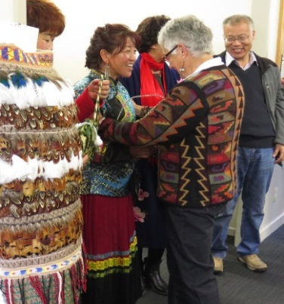 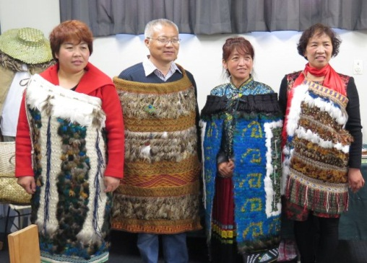

On Friday afternoon the Branch organised a workshop/demonstration of Chinese handicrafts at the Palmerston North City Library. This was opened by the Palmerston North mayor Grant Smith and was well attended by local handicraft workers and members of the public.

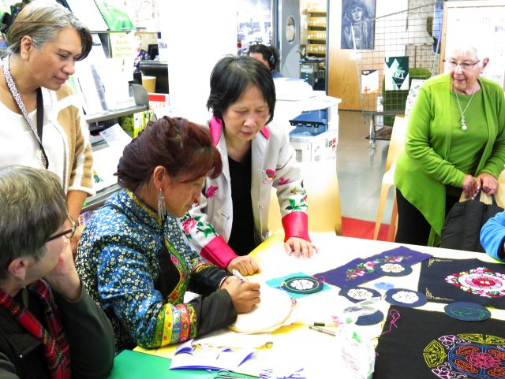 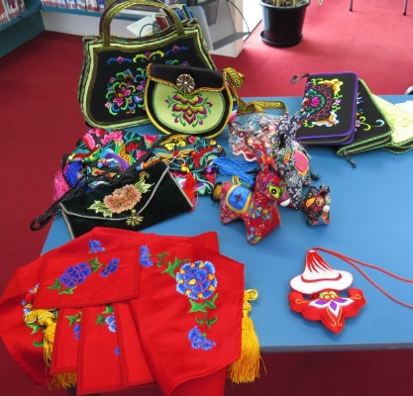

*Some of the handicraft items exhibited by the visiting Chinese delegates*

*Zhu Ernu demonstrates Tu-style embroidery to Kate Lau and local embroiderers*

After the workshop, the delegates visited Wildbase Hospital and saw live kiwi and tuatara. In the evening a pot-luck dinner was held in the new ETC premises in the square and this was well attended by members from Manawatu and Whanganui. The following morning the visitors travelled north to attend the large annual Crosshills Country Fair at Kimbolton where there were more than 100 stalls with a variety of exhibits that included handicrafts from rural areas throughout the lower half of the North Island.

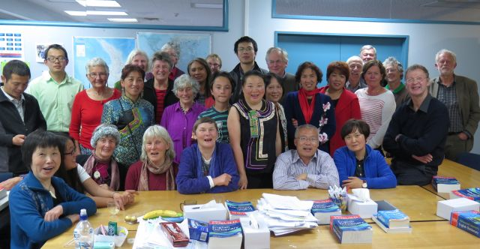

*The visiting handicraft delegation with some of the local people who joined them in a pot-luck dinner.*

XIN NIAN KUAI LE 

Best wishes for the New Year

*Maurice Alley*

*February 1st 2016*